SERVICES AT 3PM
IN UPPER CHURCH
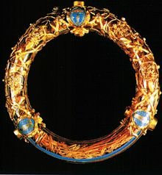
Crown of Thorns, Notre Dame Cathedral, Paris

