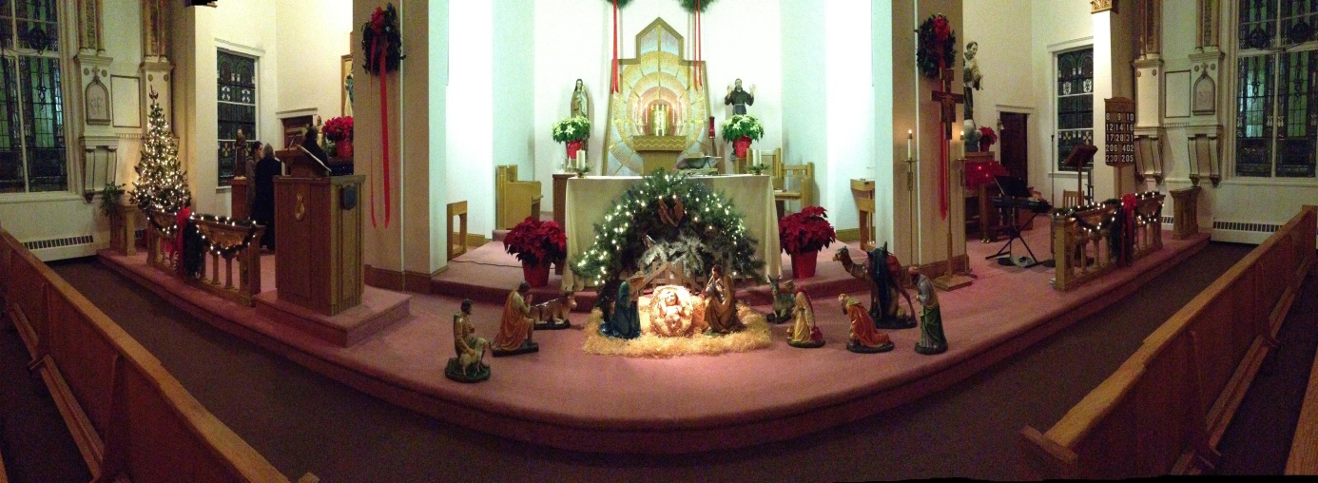

Christmas Midnight Mass
At
St. Francis of Assisi
325 Cambridge St., East Cambridge

Please join us for Christmas Carols at 11:30

Traditional Procession following Mass accompanied by Tu Sciendi Dalle Stelle
Mass Christmas Day at 9:30 am

