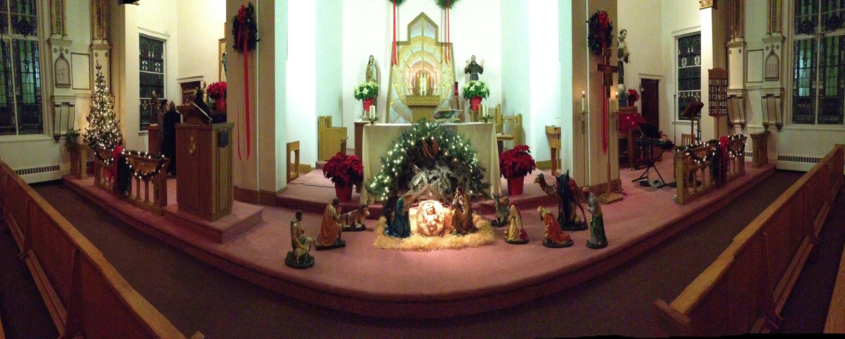

Christmas Midnight Mass
At
St. Francis of Assisi
325 Cambridge St., East Cambridge
Guest Celebrant and Choir
Please join us for Christmas Carols at 11:30
Traditional Procession following Mass accompanied by Tu Sciendi Dalle Stella

